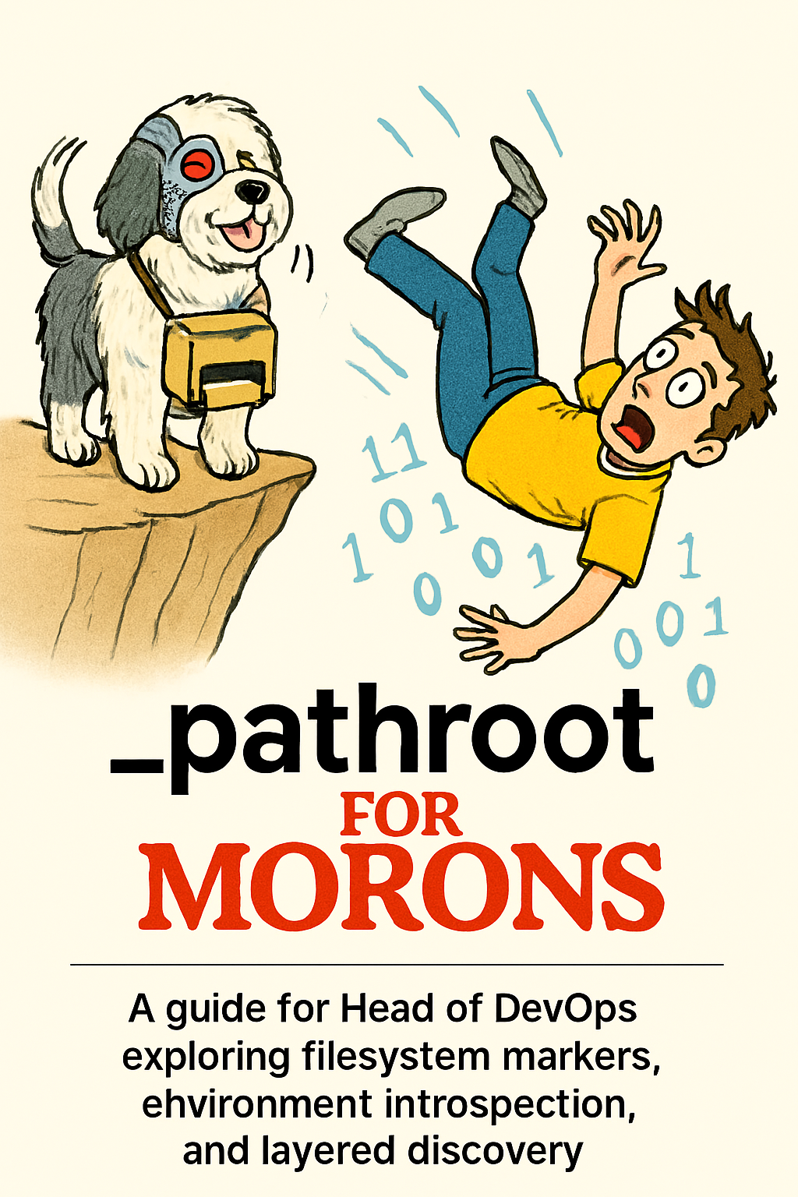

📘 _pathroot for morons

An Open Guide to Modular Devtools Environments

🧠 Introduction
Welcome, Head of DevOps. This guide is your walkthrough of a modular devtools scaffold built for clarity, introspection, and automation. It’s designed to be teachable, tweakable, and explainable—so you can understand not just what it does, but why it does it.
As you read, consider:
- What assumptions are being made?
- How might this scale or evolve?
- What would you do differently?

🧭 The Problem We’re Solving
Modern dev environments are messy. Scripts break when paths change. Tools get lost in the filesystem. Configs are duplicated or hardcoded.
We want a system that:
- Can be discovered from anywhere
- Knows what kind of environment it’s in
- Is easy to scaffold, inspect, and automate

🏗️ The Solution: Two Markers, Two Roles

1. C:\_pathroot
Global marker that tells any tool: “Here’s the root of the devtools universe.”
- 📍 Placed at the drive level
- 🧭 Used for system-wide discovery
- 🧱 Contains: C:\devtools

2. C:\devtools\_envbase
Local metadata that describes the environment.
- 🧪 Used for introspection
- 🧠 Contains JSON like:
json
{
"env": "devtools",
"profile": "default",
"platform": "windows"
}

📦 Directory Structure
C:\devtools\
├── bin\ # Executables
├── scripts\ # Utility scripts
├── config\ # Config files
├── logs\ # Log outputs
├── temp\ # Temporary files
├── tools\ # Installed packages
├── _envbase # Local environment metadata
C:\_pathroot # Global root marker

⚙️ Automation Script: automkdir.bat
This script scaffolds the entire structure and writes both markers. It’s dry-run safe and repeatable.

🧪 Introspection Script: envbase.ps1
Reads _pathroot, locates _envbase, and prints environment metadata. Useful for tooling, debugging, or profile switching.

🧠 Why These Choices?
Feature | Reason
Global marker | Enables discovery from any location
Local metadata | Keeps environment logic self-contained
Declarative | Easy to inspect, version, and automate
Modular layout | Separates concerns (scripts, logs, config)

🧩 Open Questions for You
- Would you prefer a registry-based marker over a file-based one?
- Should _envbase support multiple profiles or overlays?
- How would you handle cross-platform discovery (e.g., WSL, macOS)?
- Would you want a CLI tool to manage these markers interactively?

🧰 Next Steps
- Clone or unzip the scaffold
- Run automkdir.bat
- Inspect with envbase.ps1
- Customize _envbase to reflect your environment

❓ FAQs for Absolute Imbeciles

Because everyone starts somewhere, and some of us start further away than others.

🧭 What is _pathroot and why is it on my C: drive?
_pathroot is a file that tells your system where the devtools live. It’s like a treasure map with only one clue:
“Go to C:\devtools.”
Any script or tool can read this file and instantly know where to find the good stuff—your binaries, configs, logs, and more.

🧪 What is _envbase and why is it inside C:\devtools?
_envbase is the local brain of your devtools environment. It contains metadata like:
json
{
"env": "devtools",
"profile": "default",
"platform": "windows"
}
This helps tools know what kind of environment they’re in—like whether it’s Windows, WSL, or a test profile.

🧱 Why do we need both _pathroot and _envbase?
Because one tells you where you are (_pathroot), and the other tells you what you are (_envbase).
Think of _pathroot as the GPS coordinates, and _envbase as the weather report.

🛠️ What happens if I delete _pathroot?
Your tools will get lost. Scripts won’t know where to look. Your Head of DevOps will sigh audibly. Just don’t do it. If you did, recreate it with:
cmd
echo C:\devtools > C:\_pathroot

🧨 What happens if I delete _envbase?
Your tools will still find the devtools root, but they won’t know what kind of environment they’re in. It’s like waking up in a hotel room with no idea what city you’re in.

🧠 Can I rename _pathroot to something cooler?
You can, but you’ll break everything unless you update all your scripts to look for the new name. Stick with _pathroot. It’s boring, but it works.

🧪 Can I have multiple _envbase files?
Yes, but only if your tooling supports it. You could use:
- _envbase.default
- _envbase.test
- _envbase.wsl
Then switch between them with a script. But keep one active at a time unless you like chaos.

🧰 Can I move C:\devtools somewhere else?
Yes, but you must update C:\_pathroot to point to the new location. Otherwise, your tools will be looking in the wrong place like a dog sniffing the wrong tree.

🐶 Why is there a cyborg sheepdog on the cover?
Because this system is designed to rescue you from falling into bytecode hell. And because it’s funny. And because your Head of DevOps deserves joy.

📎 Appendices: Scripts & Scaffolds

Appendix A: Create _pathroot File (Windows CMD)
cmd
:: Create _pathroot file pointing to devtools root
echo C:\devtools > C:\_pathroot

Appendix B: Read _pathroot in PowerShell
powershell
# Read _pathroot and store in variable
$Pathroot = Get-Content -Path "C:\_pathroot"
Write-Host "Devtools root is at: $Pathroot"

Appendix C: Create _envbase File (PowerShell)
powershell
# Create _envbase file with basic metadata
$envbase = @{
env = "devtools"
profile = "default"
platform = "windows"
}
$envbase | ConvertTo-Json -Depth 3 | Set-Content -Path "C:\devtools\_envbase"

Appendix D: Read _envbase and Parse JSON (PowerShell)
powershell
# Read and parse _envbase metadata
$envbase = Get-Content -Path "C:\devtools\_envbase" | ConvertFrom-Json
Write-Host "Environment: $($envbase.env)"
Write-Host "Profile: $($envbase.profile)"
Write-Host "Platform: $($envbase.platform)"

Appendix E: Dry-Run Link Creation (LFE)
lisp
(defun dry-run-link (src dst)
(io:format "~s would link to ~s~n" (list src dst)))

Appendix F: Registry Discovery Script (Guile)
scheme
(define (read-pathroot)
(call-with-input-file "C:/_pathroot"
(lambda (port) (read-line port))))

(display (string-append "Devtools root: " (read-pathroot)))

Appendix G: Safe Link Creation with Audit Log (PowerShell)
powershell
# Create symbolic link and log action
$src = "C:\devtools\bin\tool.exe"
$dst = "C:\tools\tool.exe"
New-Item -ItemType SymbolicLink -Path $dst -Target $src
Add-Content -Path "C:\devtools\logs\link-audit.txt" -Value "$dst -> $src"



